|  |  |  |  |  |
| --- | --- | --- | --- | --- |
|  |  | | | |
|  | |  | | |
| Project: | | University Bazaar System (UBS) | | |
| Team No.: | | Team 6 | | |
| Class: | | CSE 3310; Spring 2021 | | |
| Module: | | System Requirements Analysis (SRA) | | |
| Deliverable: | | SRA Document | | |
| **Version:** | | **[1.0]** | **Date:** | **[04/01/2021]** |

Contributors

Resha Adhikari

Anfal Chaid

Nimita Uprety

Nischal Rana

**Revision History**

|  |  |  |  |  |
| --- | --- | --- | --- | --- |
| ***Version number*** | ***Date*** | ***Originator*** | ***Reason for change*** | ***High level description of changes*** |
| 1.0 | 04/01/2021 | Team6 | Initial draft | Completed SRA |
| 1.1 | 5/4/2021 | Anfal Chaid | Secondary draft | Fixes and updates |
|  |  |  |  |  |
|  |  |  |  |  |

TABLE OF CONTENTS

**1. Introduction and Project Overview**3

**2. Objectives**4

2.1 BUSINESS Objectives 4

2.2 SYSTEM Objectives 5

**3. Project** **Context Diagram** 6  
**4. Systems Requirements**7

4.1 “Registration” Requirements 7

4.2 “Login” Requirements 8

4.3 “Search” Requirements 9

4.4 “Payments” Requirements 10

4.5 “Sales” Requirements 11

4.6 “DMs” Requirements 12

4.7 “Forum” Requirements 13

4.8 “Clubs” Requirements 14

**5. Software Processes and Infrastructure**15

5.1 Hardware and Infrastructure 15

5.2 UML Diagrams 16

5.3 Conceptual Data Model - Database 23

5.4 Screen Shots 23

5.5 Test Plan 23

**6. Assumptions and Constraints**24

6.1 ASSUMPTIONS 24

6.2 CONSTRAINTS 24

6.3 OUT-OF-SCOPE MATERIAL 24

**7. Delivery and Schedule**25

**8. Stakeholder Approval Form**26

**Appendix:**27

1. Introduction and Project Overview

The purpose of the University Bazaar System is a sort of social media app that can be provided to UTA students and faculty. Its intent is to have functions, presented here but not limited to, for communication with other members of the app, to have a marketplace to sell and buy things locally, and to provide information and guidance on many local events and campus organizations.  
The functions are as follows:

* Registration: Students must register before they can use the system. University ID can be used as member Id.
* Login: Members must login to use the system after initial registration.
* Payments: System should be able to handle payments (Credit cards only; You do not need to validate credit cards for this project, just make them 16 digits long)
* Organizations: System should allow members to form specific organizations or clubs (e.g., chess club, math club, European students club, etc.).
* Marketplace: System should allow for buy/sell/lend/exchange of merchandise (e.g., books, household items such as TVs, furniture, etc.).
* Messages: System should allow for sending messages/emails to a single, subgroup or all members (e.g., Free Pizza at 12 in ERB 500, free movie showing in the student center, a great restaurant just opened next door, chess club tournament begins next week, etc.)
* Forums: Exchange information about any topic, of course appropriate and within legal boundaries of a university setting such as: job postings, company hiring, class information, tutoring service, attending graduate programs, conference information, job fairs, subleasing apartments, sharing rides, etc. (anything goes)
* Search: You should be able to search for events or items

2. Objectives

2.1 BUSINESS Objectives

The following is a list of business objectives:

**Objective 1**: Registration: All members must provide the following information prior to using the system:

* First Name, Middle Name {Optional}, Last Name
* Student/Faculty/Staff ID
* Home and Mailing addresses
* E-mail address

**Objective 2**: Login: All members must login to the system with a user/password that was established during Member registration stage.

**Objective 3**: Sales: The system should let users become buyers and sellers and handle interactions like buy, sell, loan, exchange, and message each other while also making sure the seller can send the sensitive payment information to the buyer.

**Objective 4:** Search: The system should let users to search for various things present on the application ranging from other user’s profile to organizations registered on the app. Searching by keyword should also be possible to search anything that the user wants to search using just a handful key words.

**Objective 5:** Forum: The system should provide a platform for all the users to share information about relevant topics within legal boundaries. Topics are relevant to University settings and loosely include Class Information, Meeting Information, Job Postings, Job Fairs, Organization/Clubs Information and on and on.

**Objective 6**: Payment: This system should let the user make an order, and choose the desired form of payment, namely cheque or card. This system calculates the individual price of an item, adds tax to it, calculates the total price after adding shipping fee. After the payment is made, the user can see the order of their status: order received, processing, shipped, and delivered.

**Objective 7**: DMs: This system should provide a platform for all the users to send and receive messages. The message recipient can be an individual or a group of people. Messages can include images, video, and audio.

**Objective 8**: Clubs: This system should provide a platform for all the users to form clubs, register for already existing clubs, invite regular students into the club, and run or vote for club elections and have the option to pay to receive merchandise.

2.2 SYSTEM Objectives

The following is a list of system objectives:

**Objective 1**: System will be an Android application

**Objective 2**: Search functionality will utilize Google’s search

**Objective 3**: SQL-Lite will be used to save limited amount of data

**Objective 4:** A database will be used to store registered user login information (username, password, ID, email, etc.) 3. Project Context Diagram

4. Systems Requirements

4.1 “Registration” Requirements

|  |  |
| --- | --- |
| Requirement Title: | Login & Registration |
| Sequence No.: | 001 |
| Short Description: | Allow users to register as members for the first time. This is shown as a separate link in the login page:   * under the “enter password” box   when pressed, gives user a prompt to fill out the following attributes:   * name * middle name (optional) * last name * email * student ID * username * password |
| Description: | This is a separate case function that can be used if the user does not have an account already. This function. |
| Pre-Conditions: | Users (external entity) must not already have an account.  Application must not have an account logged in at the time. |
| Post-Conditions: | Account information must be stored in a database  When registered, log in to the application |
| Other Attributes: | None |

4.2 “Login” Requirements

|  |  |
| --- | --- |
| Requirement Title: | Login & Registration |
| Sequence No.: | 002 |
| Short Description: | Simple login screen the shows up when opening the application for the first time.  Will have the app logo at the top of the screen, followed by the login prompt.  The boxes prompt the user to fill out the following attributes:   * username (or student ID) * password |
| Description: | This is a separate case function that can be used if the user does not have an account already. This function . |
| Pre-Conditions: | User (external entity) must already have an account.  Application must not have an account logged in at the time. |
| Post-Conditions: | When logged in, the application must remember account information, and automatically log in with every new app session. |
| Other Attributes: | An option to link to register as a new user, placed under the login boxes.  A “forgot password” link under the password prompt |

4.3 “Search” Requirements

|  |  |
| --- | --- |
| Requirement Title: | Search |
| Sequence No.: | 001 |
| Short Description: | Provide search bar to users |
| Description: | Provide a search bar for users to search for anything from other user’s profiles to different event information. User can enter following things into search bar:   * Keywords * Another User’s Profile name * Organization names * Event names * Item names   User can press:   * Search * Cancel   Search bar will try to match the closest key word possible but will present “Nothing Found” if nothing is matched. |
| Pre-Conditions: | Users must have already been registered and logged in. |
| Post-Conditions: | None |
| Other Attributes: | None |

4.4 “Payments” Requirements

|  |  |
| --- | --- |
| **Requirement Title:** | Payments |
| **Sequence Number:** | 001 |
| **Short Description:** | Enable payment for the orders |
| **Description:** | The following information will be collected:   * Name of Items * Number of Items * Price of each item * Form of Payment * Credit card/debit card/cheque information   The following information is established through the app:   * Tax applied on each item * Price of Item after tax * Total cost of items after adding shipping fee   User can press:   * Checkout * Cancel Order * Exit screen (or close) |
| **Pre-Conditions:** | * User must have already registered and logged in * Duplicate card/cheque information is not allowed |
| **Post-Conditions:** | * All “Saved” changes will be kept permanently * The order status should be visible to the user |
| **Other Attributes:** | * None |

4.5 “Sales” Requirements

|  |  |
| --- | --- |
| **Requirement Title:** | Sales |
| **Sequence Number:** | 001 |
| **Short Description:** | Buy, sell, exchange or loan merchandise to the people in the group |
| **Description:** | The following information will be collected:   * Selection whether the person is buyer or seller * Selection of category from gadgets, furniture, and stationery * Seller’s choice on sorting with category, price, date listed or alphabetical order * Buyer’s selection on selling, loaning, and exchanging merchandise * Pictures and condition of merchandise listed by buyers * Price agreement from buyer and seller * Delivery options, warranty selection by buyer and seller * Payment information of buyer   User can press:   * Buy * Sell * Mark as sold * DM buyer/seller * Exit screen (or close) |
| **Pre- Conditions:** | * User must select buyer or seller option * To be a seller, they must upload pictures and set price for merchandise |
| **Post- Conditions:** | * Items mark as sold will be removed |
| **Other Attributes:** | * None |

4.6 “DMs” Requirements

|  |  |
| --- | --- |
| **Requirement Title:** | DMs |
| **Sequence Number:** | 001 |
| **Short Description:** | Send a DM to a person or a group |
| **Description:** | The following information will be collected:   * Name/id of person to whom the DM is to be sent * Name/id of multiple people if it is a group message * User typed message that is to be sent * Image, video, and audio if want to be included in the message * User cannot make a call     User can press:   * Send * Cancel * Exit screen (or close) |
| **Pre- Conditions:** | * User must have logged in already * If multiple people have same name, user must identify the message recipient through their user ID |
| **Post- Conditions:** | * All “sent” messages will be kept permanently * If deleted, messages are only removed on the sender’s end |
| **Other Attributes:** | * None |

4.7 “Forum” Requirements

|  |  |
| --- | --- |
| Requirement Title: | Forum |
| Sequence No.: | 001 |
| Short Description: | Present as the main component of the app to everybody where they can share information about relevant topics. |
| Description: | Provide a platform for all the users to share information about relevant topics within legal boundaries. Topics are relevant to University settings and can be any of the following and related topics:   * Thoughts for the day * News * Job Postings/Company Hiring * Class Information * Tutoring Service/Information * Conference Information * Job Fairs * Subleasing Apartments * Sharing Rides   User can press:   * Post * Cancel   Users can view other user’s posts and can open them to comment or see other user’s comments. |
| Pre-Conditions: | Users must have already been registered and logged in. |
| Post-Conditions: | If User decides to cancel the post, store temporarily the contents and ask whether User truly wants to cancel the post by letting them know that the contents will be erased.  If User confirms a post, then the content is stored permanently along with information of the user who posted it. |
| Other Attributes: | Temporarily store contents typed in the Post in buffer before User posts it or cancels it.  If User posts it then the contents are held permanently.  If User cancels it then the contents are erased. |

4.8 “Clubs” Requirements

|  |  |
| --- | --- |
| Requirement Title: | Clubs |
| Sequence No.: | 001 |
| Short Description: | Let the students join, leave, and organize events for the clubs |
| Description: | The following options are provided for the regular students for the prospective organizations:   * form clubs * let members register for already existing clubs * let existing members invite regular students into club * Run or vote for club elections once a member * Announce upcoming meetings and college events if event organizer for the club * sign up to receive club merchandise if they pay for merchandise   User can press:   * Join club * Form club * Invite members * Vote/Run for Club Elections * Pay to receive merchandise |
| Pre-Conditions: | Students can join multiple clubs  Require approval of club leader to become a candidate for club elections |
| Post-Conditions: | None |
| Other Attributes: | None |

5. Software Processes and Infrastructure

5.1 Hardware and Infrastructure

This project utilizes Android Studio written in Java programming language using Android version KitKat.

The team will work together by the use of a git repository. The repository will hold all the source code needed to create the application, and to deploy the application.

When testing, an android emulator will be utilized. This android emulator will allow the team to focus on how the application will look from a user perspective— or *usability* testing.

5.2 UML Diagrams

**UML-ClassDiagram-System**

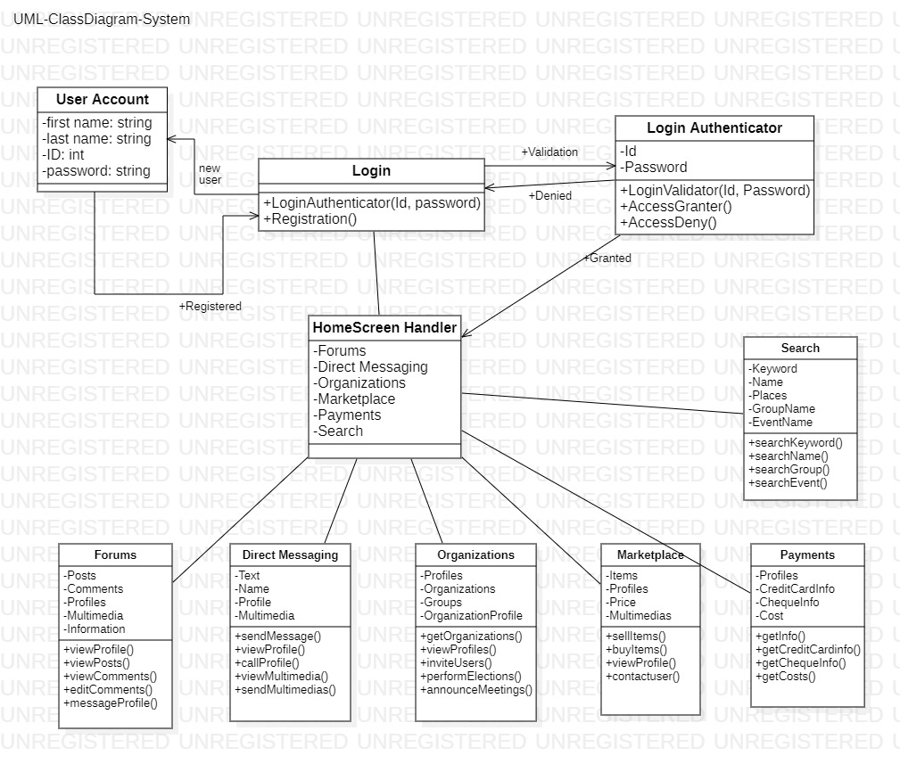

**UML-ActivityDiagram-DirectMessaging**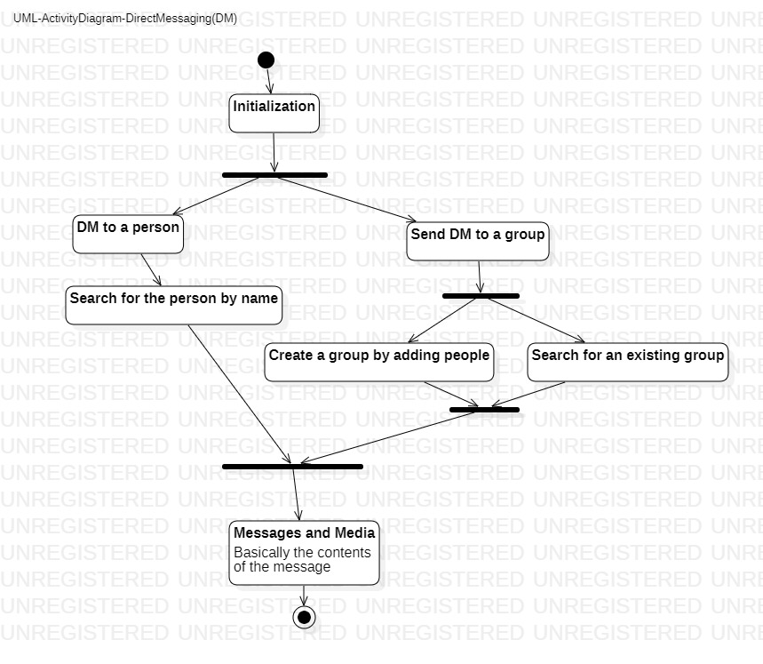

**UML-ClassDiagram-Payments**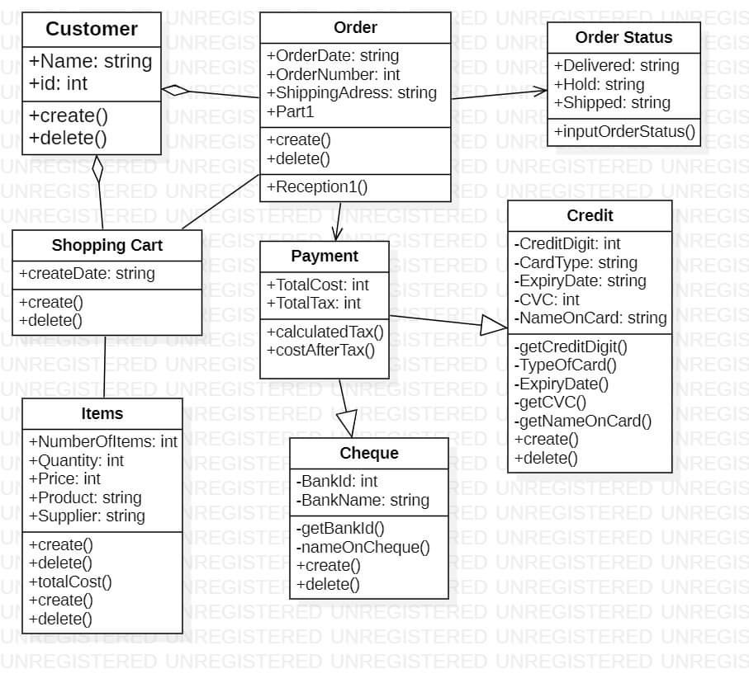

**UML-ActivityDiagram-F****orums**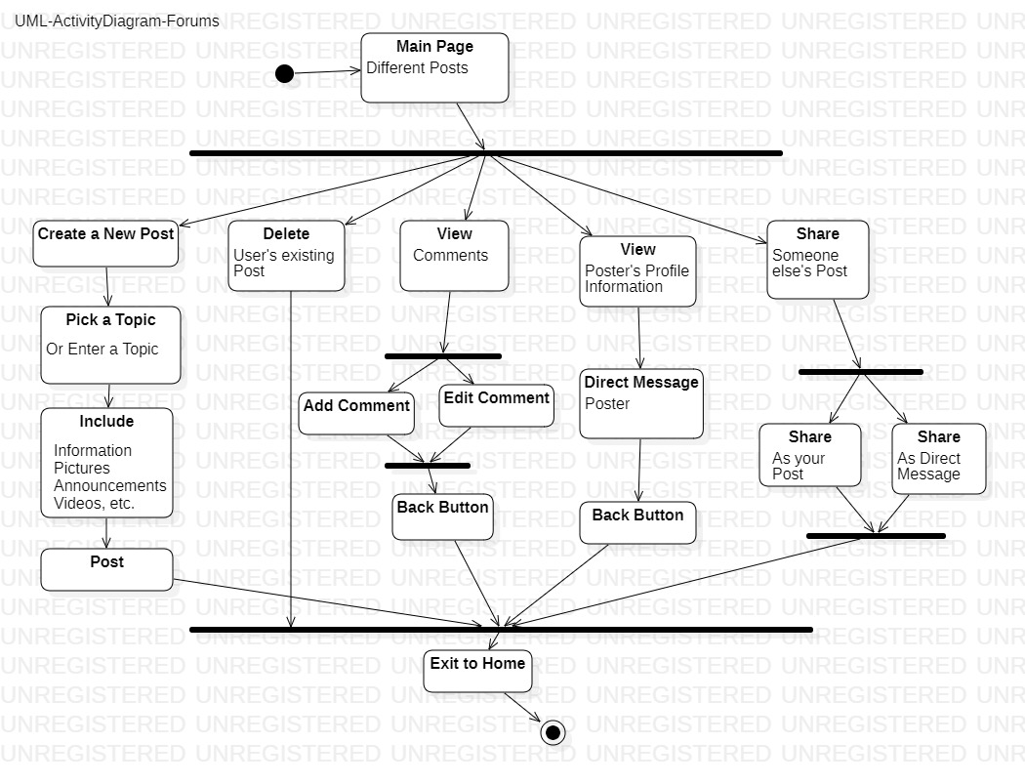

**UML-ActivityDiagram-Search**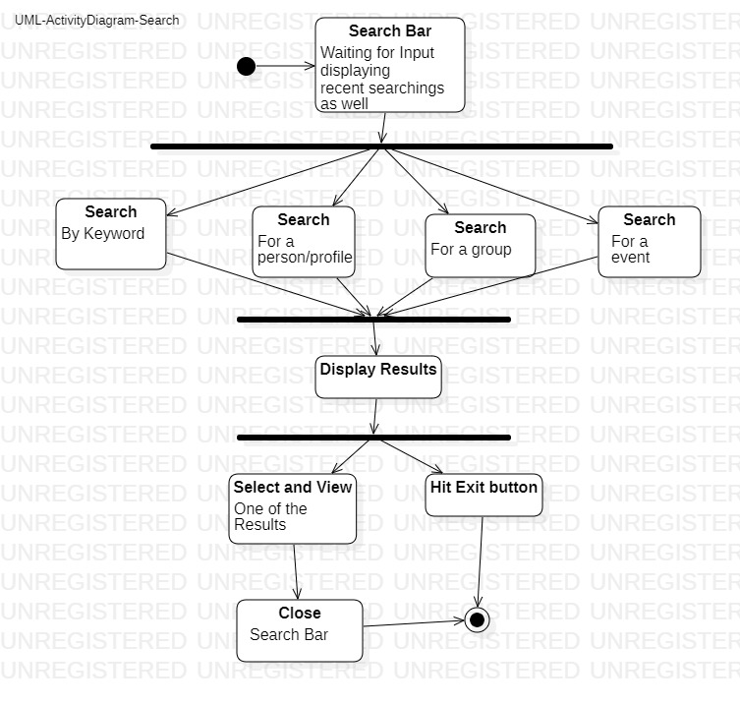

**UML-ActivityDiagram-Organizations**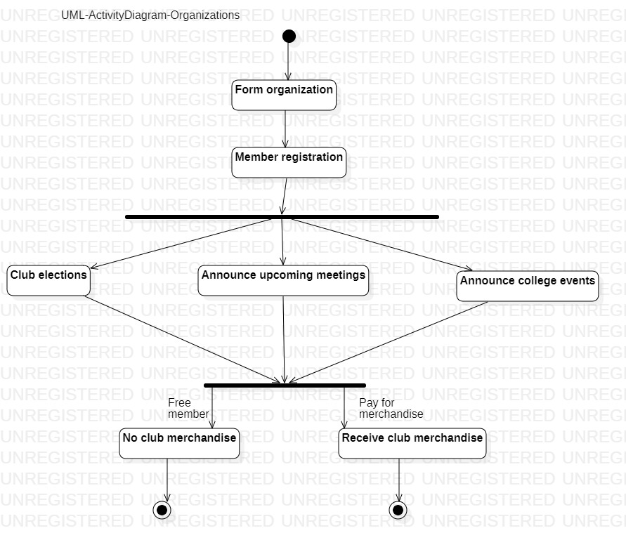

**UML-StateTransitionDiagram-Marketplace**

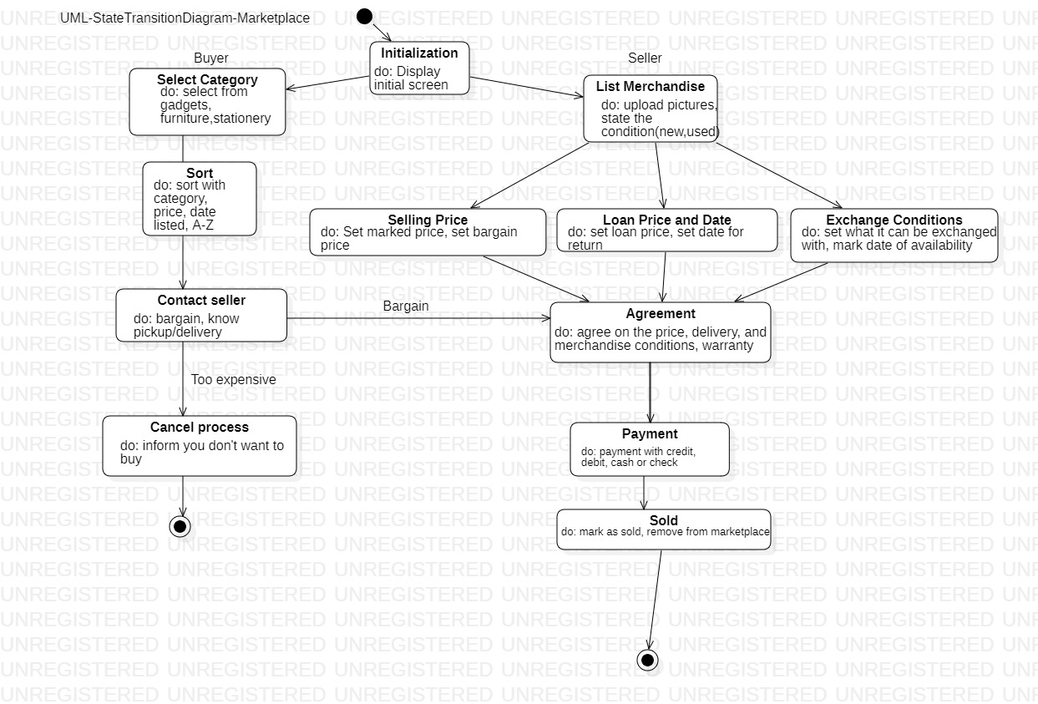

5.3 Conceptual Data Model - Database

Not available at this moment.

5.4 Screen Shots

Not available at this moment.

5.5 Test Plan

At the moment, the team plans to use the Android studio emulator to test every part of the project as it develops. Android studio emulator will be helpful in letting the team understand in which direction to go feature wise, and allows for the use of utility testing and feature testing.

6. Assumptions and Constraints

6.1 ASSUMPTIONS

The following is a list of assumptions:

* Ignore collecting money from external advertisement and general accounting.
* Ignore compliance issues.
* Users registering to create and account are all over the age of 18.
* Users are regarded as UTA personnel as in students attending classes or faculty members and staff.
* Users are regarded as familiar with the use of application as the tutorial is not created/present.

6.2 CONSTRAINTS

The following is a list of constraints:

* Team lacks rigid android experience — everything will be learned as this project develops.
* Schedule very aggressive — 1 month schedule to complete the application

6.3 OUT-OF-SCOPE MATERIAL

The following is a list of “out of scope” material:

* Post Project maintenance is not covered.
* Ability to make calls in the DM section. A future feature of the application will allow the user to call other users via DM feature.

7. Delivery and Schedule

|  |  |  |  |  |
| --- | --- | --- | --- | --- |
| Task/Milestone Description | Anticipated Start Date | Anticipated End Date | Status | Comments |
| Prepare Requirements and UML diagram | 02/4/2021 | 03/4/2021 | Complete | Deliverable UML document. Increment 1 Deliverable |
| SRA document (Includes project objectives, Requirements and UML diagrams) | 03/16/2021 | 04/1/2021 | In Progress | Deliverable will be the SRA document. All stakeholders agree on the content of the SRA by signing in section 8.  Increment 2 Deliverable |
| Home screen design and implementation | 03/20/2021 | 04/20/2021 | To Be Completed (TBC) |  |
| Login and registration design and implementation | 04/02/2021 | 04/20/2021 | TBC |  |
| Forums Design and Implementation | 04/02/2021 | 04/20/2021 | TBC |  |
| Search Bar Design and Implementation | 04/02/2021 | 04/20/2021 |  |  |
| Payments Design and Implementation | 04/02/2021 | 04/20/2021 | TBC |  |
| DMs Design and Implementation | 04/02/2021 | 04/20/2021 | TBC |  |
| Sales Design and Implementation | 04/02/2021 | 04/20/2021 | TBC |  |
| Clubs Design and Implementation | 04/02/2021 | 04/20/2021 | TBC |  |
| Test case design | 4/06/2021 | 4/22/2021 | TBC | Increment 3 Deliverable |
| External Documentation (i.e., User Manual) | 4/23/2021 | 5/4/2021 | TBC |  |
| Project presentation | 4/27//2021 | 5/4/2021 | TBC |  |
| Final Milestone: project delivery | 4/27/2021 | 5/4/2021 | TBC | Increment 4 Deliverable |

8. Stakeholder Approval Form

|  |  |  |  |
| --- | --- | --- | --- |
| Stakeholder Name | Stakeholder Role | Stakeholder Comments | Stakeholder Approval Signature and Date |
| Bahram Khalili | Development Mgr |  |  |
| Akshit Singhal | Project Assistant |  |  |
| Anfal Chaid | Developer | Chaid, Anfal | 4/1/2021 |
| Resha Adhikari | Developer | Adhikari, Resha | 4/1/2021 |
| Nischal Rana | Developer | Rana, Nischal | 03/31/2021 |
| Nimita Uprety | Developer | Uprety, Nimita | 4/1/2021 |

***{All team members must sign and Date before submitting your SRA}***

Appendix:

None